**Project Proposal: Shopping Management System**

**Problem Overview**

To develop a Java Swing Application that allows a registered customer to purchase a

variety of products sold by a list of registered vendors.

To have the Wholesaler inventory where - the admin and the vendors would have access to update it; Customers to have the ability to do secure registration and manage their profiles. To implement secure payment gateway for the customers and vendors. To allow vendors to add, modify or delete the already posted items. Administrators to have the authority to approve and reject requests for new items and have access to control customer and vendor actions.

**Proposed Entities**

**Enterprises**

1. Manufacturer / Seller / Wholesaler / Retailer
2. Marketplace

**Organizations**

1. User Account Directory
2. Marketplace Customer Directory
3. Vendors Directory
4. Admin Organization
5. Delivery Organization

**Key Features**

1. Shopping cart for customers grouped by category and seller

2. Each shopping item will have image, description, name, stock quantity and price

3. Sign Up/ Sign In for customers, Market admin, Seller and Wholesaler admin

* Sign Up (Name, Email, Username, Password, Card Number(Optional))
* Sign In (Username, Password)
* Forget Password feature
* Password to be sent to the User Email Address, Password Recovery
* Password Show / Hide feature
* Username Validation (Check if username already exists in the DB, should be unique)

4. Product Information

5. Adding to Cart feature with quantity input from customer

6. Validation for Quantity input (display message if quantity input > stock quantity)

7. Cart View should have a table with these columns

* Product Name
* Model
* Price
* Quantity

Total Bill in the cart and a Buy feature.

8. Search feature for the customers to search for products

9. On Buy from Cart View, Enter delivery address modal window

10. Account Information of a user

11. Sign Out Feature

12. Admin Login and Administrative panel

13. Administrative Panel

* Seller Entry
* Delete Seller Entry and it’s products
* Billing Log to track all the purchases by a customer and all orders received by a seller.

14. Seller login and Seller panel

15. Seller Panel

* Product entry
* Delete product
* Update quantity
* Check product performance.

16. Data Analytics

* Buy one get one feature

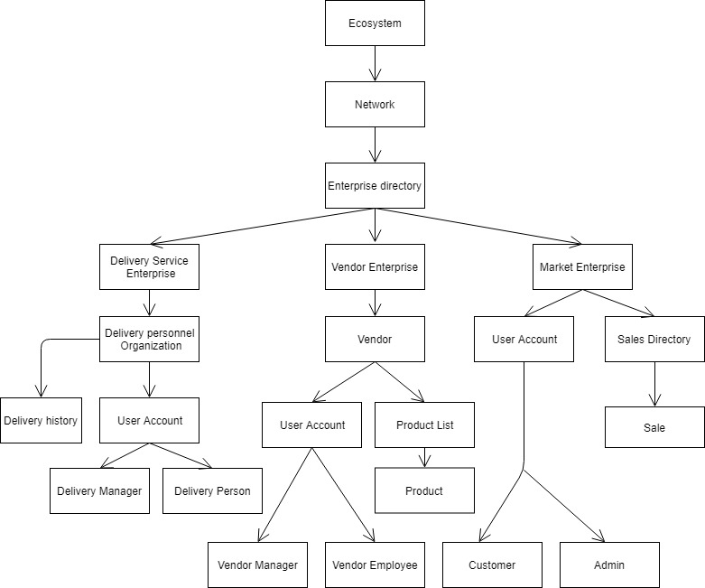**Ecosystem Architecture Diagram**

**Tasks:**

1. **Login/ Register functionality with Forget Password**
2. **Customer Panel – Products separated by category**
3. **Vendor Panel**